**Project Design Phase**

**Problem – Solution Fit Template**

|  |  |
| --- | --- |
| Date | 15 February 2025 |
| Team ID | LTVIP2025TMID59486 |
| Project Name | ShopEZ: One-Stop Shop for Online Purchases |
| Maximum Marks | 2 Marks |

**Problem – Solution Fit Template:**

The Problem–Solution Fit ensures that ShopEZ directly addresses the key pain points faced by online shoppers and sellers. Identifying and validating these challenges ensures the platform is built around actual customer needs before further scaling or enhancement.

**Purpose:**

* Simplify the online shopping journey from product discovery to final checkout.
* Create a centralized platform for browsing, filtering, and buying a wide range of products.
* Empower sellers with tools to manage inventory, orders, and customer insights.
* Enhance shopping decisions through reviews, ratings, and personalized recommendations.
* Build user trust with secure login, real-time order tracking, and admin moderation.

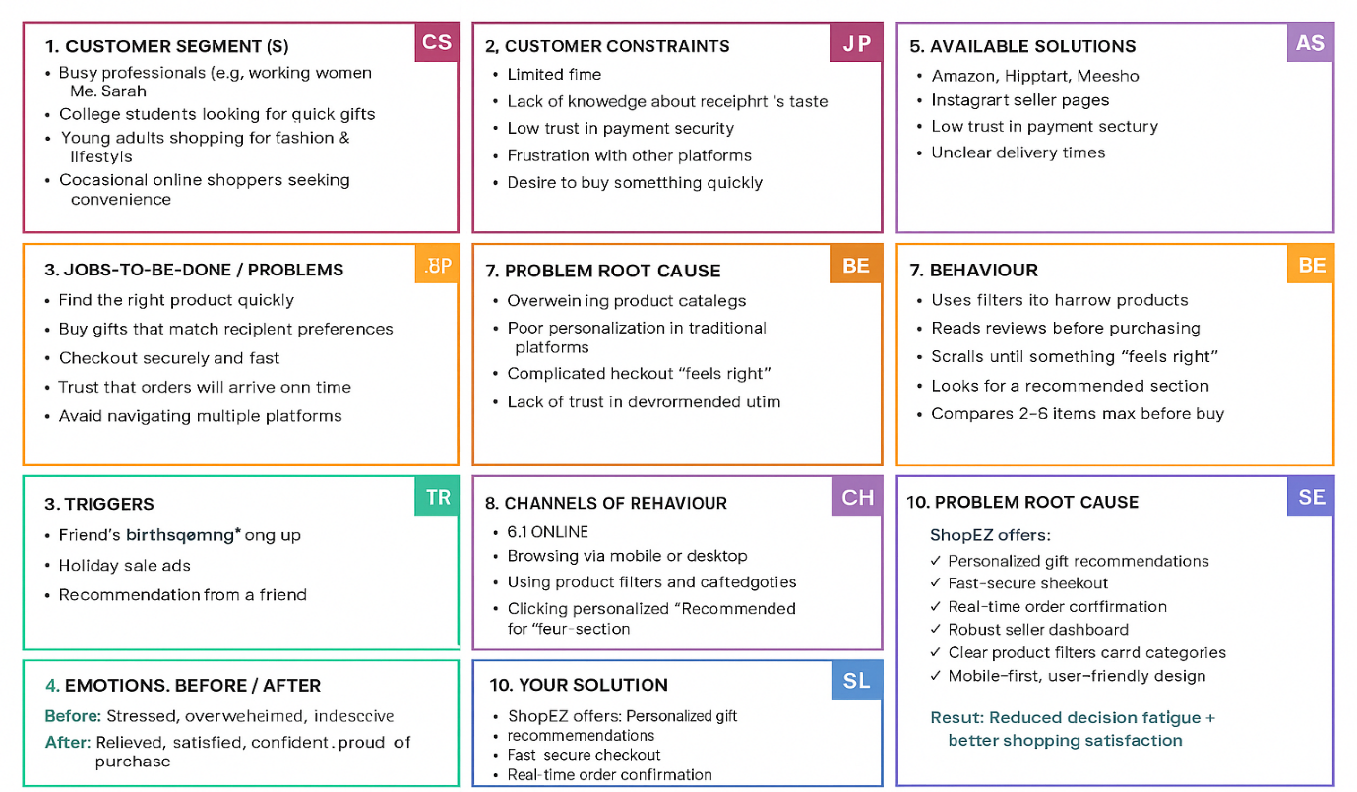**Template:**

References:

1. <https://www.ideahackers.network/problem-solution-fit-canvas/>
2. <https://medium.com/@epicantus/problem-solution-fit-canvas-aa3dd59cb4fe>

References:

1. <https://www.ideahackers.network/problem-solution-fit-canvas/>
2. <https://medium.com/@epicantus/problem-solution-fit-canvas-aa3dd59cb4fe>